Chapter 12 Food and energy

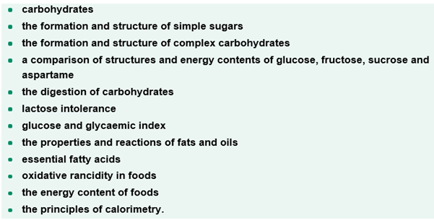

Test 12
Section A (20 marks)
1. When two monosaccharides react to form a disaccharide
A. an ester bond forms
B. a glycosidic bond forms
C. a peptide bond forms
D. a aldehyde bond forms

2. Which of the following statements about glucose, galactose and fructose is incorrect?
A. They all have the general formula C_{x}(H₂O)_{y}
B. They are described as being simple sugars
C. They are all equally sweet
D. They all have the same energy content

3. Which of the following statements about the polysaccharides starch, cellulose and glycogen is incorrect?
The polysaccharides starch, cellulose and glycogen are all
A. non-crystalline and generally soluble in water
B. broken down in the body with the use of enzymes
C. comparatively tasteless
D. composed of large numbers of monosaccharide monomers

4. Cellulose
A. is the major storage form of glucose in plants
B. is digested readily in humans to release energy during respiration
C. is an addition polymer of α-D-glucose
D. is the main structural component of cell walls in plants.
5. The chemical process by which fats and carbohydrates are broken down in our digestive system is
A. hydrolysis
B. hydration
C. condensation
D. substitution

6. Fats and oils belong to a group of compounds called lipids. They form in the reaction between fatty acid molecules and a glycerol molecule.
All fats and oils
A. contain an ether functional group and are polar
B. contain an ether functional group and are non-polar
C. contain an ester functional group and are polar
D. contain an ester functional group and are non-polar

7. The complete hydrogenation of 2.78 g of linolenic acid (C₁₇H₂₉COOH) required 744 mL of hydrogen gas at SLC.
The number of C=C double bonds in linolenic acid is
A. 1
B. 2
C. 3
D. 4

8. In the following flow diagram,
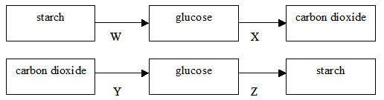
the processes where water is firstly a reactant and secondly a product are
A. W and Y
B. W and X
C. X and Z
D. Y and Z

9. Some triglycerides are susceptible to oxidation resulting in them becoming rancid. This occurs more in triglycerides that
A. readily undergo condensation reactions
B. are hydrolysed to form fatty acids and glycerol
C. are in the presence of antioxidants
D. are formed from unsaturated fatty acids

10.
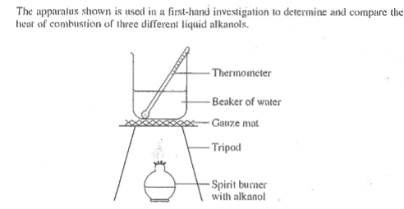
Which is the independent variable?
A. the type of alcohol used
B. the amount of water used
C. the amount of alkanol used
D. the temperature change in the water

Section B (30 marks)
1. < the structures below (labelled A – J) can be spread randomly beside each other or under each other (anywhere really!) just as long as the structures are clearly associated with their letter label >
The structures below (labelled A – J) represent a random listing of the molecules listed in the following table.
Place the letter corresponding to the structure in the table. Each letter can be used only once.

Molecule | Letter corresponding to the structure of the molecule
a sweetener 200 times sweeter than sucrose
a saturated fatty acid
glycerol
a disaccharide formed before glucose when starch is digested
a polysaccharide that is the major storage form of glucose
an omega 3 unsaturated fatty acid
a polysaccharide formed from β-D-glucose molecules
α-D-glucose
a triglyceride
a disaccharide formed from one α-D-glucose molecule and one fructose molecule
[10 x ½]

A 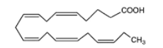

B 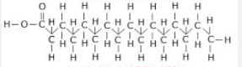

C 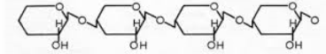

D 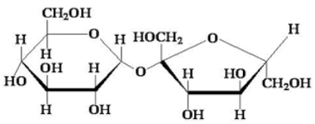

E 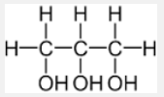

F 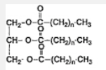

G 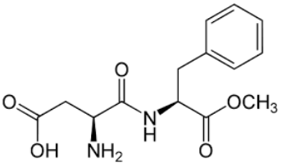

H 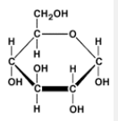

I 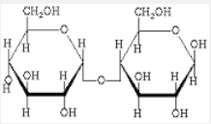

J 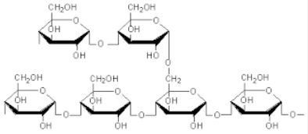

2. A food product has the following nutrtional information:
 | per 100 g
Protein (g) | 10.6
Fat TOTAL (g) | 4.1
- Saturated | 1.8
- Trans fat | 0.0
- Polyunsaturated | 1.3
- Monounsaturated | 1.0
Carbohydrate TOTAL (g) | 71.3
- sugars | 9.9
Dietary fibre (g) | 8.9
Sodium (mg) | 260
Potassium (mg) | 275
Thiamin (Vitamin B1) (mg) | 1.15
Riboflavin (Vitamin B2) (mg) | 0.89
Niacin (Vitamin B3) (mg) | 5.2
Folate (μg) | 208
Iron (mg) | 6.3
Magnesium (mg) | 90

(a) Complete the following table to determine the energy content of 100 g of this food product
Nutrient | Mass (g) | Energy (kJ g⁻¹) | Energy (kJ)
protein |  | 17
fat |  | 37
carbohydrate |  | 17
 |  | TOTAL

(b) Explain why the dietary fibre was not included in the energy calculation in part (a).
(c) What is the function of folate in the human body? [3 + 1 + 1 = 5 marks]

3. Fats and oils belong to a group of compounds called lipids. Fats are generally solids while oils are liquids. In the table below there is a list of 7 fatty acids.
fatty acid | formula | Number of double C=C bonds | melting temperature  (ºC)
lauric acid | C₁₁H₂₃COOH |  | 44
myristic acid | C₁₃H₂₇COOH |  | 54
palmitic acid | C₁₅H₃₁COOH |  | 63
stearic acid | C₁₇H₃₅COOH |  | 70
oleic acid | C₁₇H₃₃COOH |  | 16
linoleic acid | C₁₇H₃₁COOH |  | -5
linolenic acid | C₁₇H₂₉COOH |  | -17

(a) Complete the table above by determining the number of double C=C bonds in each of the fatty acid molecles.
(b) Describe and explain the tend in boiling point of the following fatty acids
(i) lauric acid, myristic acid, palmitic acid, stearic acid
(ii) stearic acid, oleic acid, linoleic acid, linolenic acid [5 marks]

4. A bomb calorimeter can be calibrated using a subtance with a known heat of combustion.
This is referred to as a chemical calibration.
A commonly used calibrating agent is solid benzoic acid
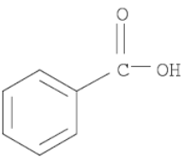

A with a B >
Benzoic acid has a heat of combustion of 3227 kJmol⁻¹.

(a) Benzoic acid comprises two major structural components which are labelled A and B. Name each of these components.
(b) 2.50 g of benzoic acid was placed in a bomb calorimeter and completely reacted with oxygen. The temperature rise of the calorimeter was observed to be 8.90^{O}C.
Determine the calibration factor for the calorimeter in kJºC⁻¹.
(c) Write the thermochemical equation, with states, for the complete combustion of benzoic acid in oxygen.
[2 + 3 + 1 = 6 marks]
5. The heat of combustion of sucrose can be determined by using bomb calorimetry. In an experiment, a current of 2.50A was passed through the electric heater of a calorimeter for 60.0s at a voltage of 5.50V. The temperature rose form 20.010ºC to 20.535ºC.
Immediately following this experiment 0.350g of finely crushed sucrose was reacted with excess oxygen in the calorimeter. The temperature subsequently rose to 24.185^{O}C.
(a) Explain why the sucrose was finely crushed.
(b) Explain why excess oxygen was used.
(c) Determine the calibration factor for this calorimeter in kJ ºC⁻¹
(d) Determine the enthalpy change in kJmol⁻¹ for the combustion of sucrose
(e) Write a thermochemical equation, with states, for the combustion of sucrose.
(f) Electrical energy in the form of a spark is needed to ignite the sample. What is this energy called?
[1 + 1 + 2 + 3 + 1 + 1 = 9 marks]

Solutions for test 12
Section A (20 marks)
1. B
2. C
3. B
4. D
5. A
6. D
7. C
n(linolenic acid) = m / M = 2.78 / 278.0 = 0.0100
n(H₂) = V / V_{m} = 0.744 / 24.8 = 0.0300
ratio: n(H₂) / n(linolenic acid) = 0.0300 / 0.0100 = 3
therefore there are three C=C double bonds in linolenic acid
8. B
9. D
10. A

Section B (30 marks) [marks are denoted by square brackets]
1.
Molecule | Letter corresponding to the structure of the molecule
a sweetener 200 times sweeter than sucrose | G
a saturated fatty acid | B
glycerol | E
a disaccharide formed when starch is digested | I
a polysaccharide that is the major storage form of glucose | J
an omega 3 unsaturated fatty acid | A
a polysaccharide formed from β-D-glucose molecules | C
α-D-glucose | H
a triglyceride | F
a disaccharide formed from one α-D-glucose molecule and one fructose molecule | D
[10x ½ ]
2(a)
Nutrient | Mass (g) | Energy (kJ g⁻¹) | Energy (kJ)
protein | 10.6 | 17 | 10.6 x 17 = 1.8 x 10²
fat | 4.1 | 37 | 4.1 x 37 = 1.5 x 10²
carbohydrate | 71.3 | 17 | 71.3 x 17 = 1.2 x 10³
 |  | TOTAL | 1.5 x 10³
< delete these two cells [6 x ½ ]
(b) The body cannot digest dietary fibre [1]
(c) Folate works along with vitamin B12 and vitamin C to help the body break down, use, and create new proteins [1]

3(a)
fatty acid | formula | Number of double C=C bonds | melting temperature  (ºC)
lauric acid | C₁₁H₂₃COOH | 0 | 44
myristic acid | C₁₃H₂₇COOH | 0 | 54
palmitic acid | C₁₅H₃₁COOH | 0 | 63
stearic acid | C₁₇H₃₅COOH | 0 | 70
oleic acid | C₁₇H₃₃COOH | 1 | 16
linoleic acid | C₁₇H₃₁COOH | 2 | -5
linolenic acid | C₁₇H₂₉COOH | 3 | -17
[1]
(b) Describe and explain the trend in boiling point of the following fatty acids
(i) The boiling points increase in the order: lauric acid <myristic acid <palmitic acid < stearic acid. [1]
This is due to the fact that the molecules are increasing in molecular mass leading to an increase in dispersion forces between molecules. [1]
(ii) The boiling points decrease in the order: stearic acid < oleic acid > linoleic acid > linolenic acid. [1]
This is due to the fact that the molecules are becoming increasing more bent due to the presence of the double C=C bonds. This results in less effective dispersion forces between the molecules. [1]

4(a) A is a benzene ring and B is a carboxyl functional group [2]

(b) n(benzoic acid) = m / M = 2.50 / 122.0 = 0.00205 mole [1]
Since one mole of benzoic acid evolves 3227 kJ of heat energy
0.00207 mole of benzoic acid will evolve (0.00205 / 1) x 3227 = 66.1 kJ [1]
Since E = CF x ΔT
CF = E / ΔT = 66.1 / 8.90 = 7.43 kJ ºC⁻¹ [1]

(c) C₆H₅COOH(s) + 15/2O₂(g) 7CO₂(g) + 3H₂O(g) ΔH = - 3227 kJ mol⁻¹ [1]
or 2C₆H₅COOH(s) + 15O₂(g) 14CO₂(g) + 6H₂O(g) ΔH = - 6454 kJ mol⁻¹

5(a) It is finely crushed to increase the surface area and enhance the rate of reaction. [1]
(b) To ensure a complete reaction [1]
(c) E = VIt = 5.50 x 2.50 x 60.0 = 825 J [1]
CF = E / ΔT
Since ΔT = 20.535ºC - 20.010ºC = 0.525ºC
CF = 825 / 0.525 = 1.57 x 10³ J ºC⁻¹ = 1.57 kJ ºC⁻¹ [1]
(d) The energy evolved in the reaction = CF x ΔT
Since ΔT = 24.185^{O}C - 20.535ºC = 3.650ºC
Energy evolved = 1.57 x 3.650 = 5.74 kJ [1]
n(sucrose) = m / M = 0.350 / 342.0 = 0.00102 mole [1]
ΔH = - energy evolved/ mole consumed = - 5.74 kJ / 0.00102 mole = - 5.60 x 10³ kJmol⁻¹ [1]
(e) C₁₂H₂₂O₁₁(s) + 12O₂(g) 12CO₂(g) + 11H₂O(g) ΔH = - 5.60 x 10³ kJmol⁻¹ [1]
(f) The activation energy [1]

